R E Q U E S T f o r Q U A L I F I C A T I O N S

ALL PROSPECTIVE FLOORING FULL SERVICE SUPPLIER & INSTALLER

INVITATION for QUALIFICATIONS
Task Order IDIQ - FLOORING
GHS-FD Project #: Bed Bundles
F2022037/F2022038/F2022045

Grady Health System Department of Facilities Development is soliciting “Qualifications” Full Service Supplier/Installer for flooring on the upcoming Grady bed expansion including a buildout 9B and 10B (formerly Cancer Canter) to 26 bed critical care units using current GMH standards, a conversion of 9th, 10th, & 11th floor C/D wings to 30 bed Med/Surge units on each floor as well as 12th floor C/D wings to a 26 bed Rehab unit. A brief overview of the project is further into this document. Grady intends to establish pricing and ordering standardization that will allow FD to utilize the awarded Supplier/Installer for future projects.

The project will be located in the clinic building of the main hospital.
- 80 Jesse Hill Jr. Drive, SE, Atlanta, GA 30303.

All appliance and accessory suppliers planning to partner and submit a proposal must be pre-qualified. To become qualified, please submit a qualifications package meeting the following requirements:
- List of three to five projects of similar size and scale.
- Brief narrative of each of the referenced projects.
- Organization chart of your team
- One page CV or resume of each team member.

Additionally, registration with VendorMate must also be completed in order to be considered pre-qualified.

Please submit qualifications to Evan Rodriguez by email at erodriguez2@gmh.edu by c.o.b. April 26th, 2023. You will be notified if you have met the threshold for being pre-qualified.

Pre-proposal meeting to be held Friday, April 28th, 2023 at Hurt Bldg Conference Center 10:00am to 11:00am

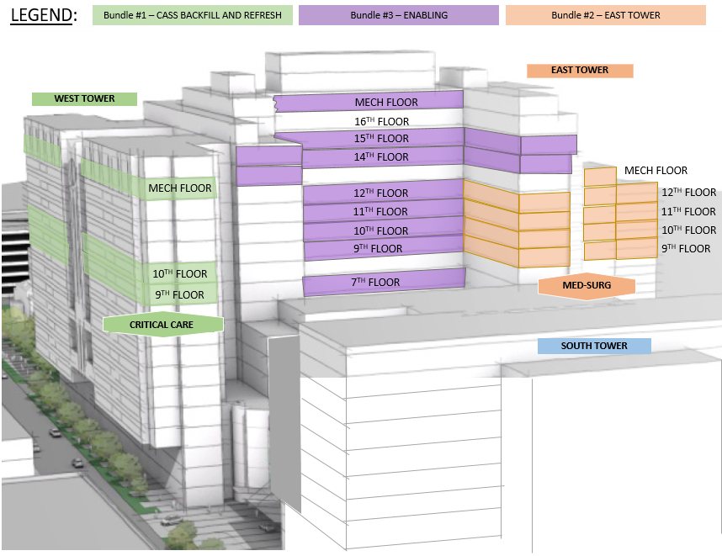
Figure #1 – Grady Bed Expansion

Local, Small Economically Disadvantaged Business Utilization
It is an overall objective of The Grady Memorial Hospital Corporation, d/b/a Grady Health System (GHS) to encourage involvement by local, small, economically disadvantaged contractors and suppliers in business activities generated by GHS®, while assuring that such activities will be conducted in accordance with all applicable laws. It is the declared policy and intent of GHS® to strive to maximize participation of local, small, economically disadvantaged businesses through all business contracting opportunities. GHS® is committed to ensuring that local, small, economically disadvantaged businesses are given every opportunity to participate in contracting opportunities.

GHS® prohibits discrimination on the basis of race, color, gender, religion, national origin, or disability in connection with employment of any person, or the award of any contract. GHS® will provide equal opportunities without regard to race, color, gender, religion, national origin, or disability, by requiring that any vendor doing business with GHS® provide equal opportunity to persons and businesses employed by, or contracting with the supplier of products and services to GHS®.

GHS® expects that the policies, programs and practices of its vendors/contractors are carried out in an equitable fashion and that local (Fulton County, DeKalb County, State of Georgia), small and economically disadvantaged business enterprises are afforded an equitable opportunity to share in contract/subcontract opportunities.

These documents are considered a part of and should be submitted with the qualifications package. Failure to provide the requested information will result in the proposal being determined non-responsive.

- Screen shot or copy of Vendormate certificate
- Completed TIER 1 Diversity form
- Certificate verifying TIER 1 diversity.
- List of three to five projects of similar size and scale.
- Brief narrative of each of the referenced projects.
- Physical location of each of the referenced projects.
- Organization chart of your team
- One page CV or resume of each team member.

PROCESS FOR SELECTION

A selection team will evaluate each qualification submitted and score the team member. The scores will be made available upon request for your team following pre-qualification

GHS-FD reserves the unqualified right to request additional information or meetings with any architect, engineer, or contractor.

Your company wishes to be pre-qualified as a:

⃝ Supplier

PATCRAFT
TARKETT
(ALTERNATE)
TAKIRON
ECORE
NORA

⃝ Installer

PATCRAFT
TARKETT (ALTERNATE)
TAKIRON
ECORE
NORA

NAME: TITLE:

PHONE: ( ) EMAIL:

SIGNATURE: DATE:

PATCRAFT – PLANKING FOR CORRIDORS AND CIRCULATION |  |  |  | 12466
Patcraft Mark Making three color pattern.
EARTHWOOD | 5 MIL | ACCENT #1 | 00750
SILHOUETTE | 5 MIL | ACCENT #2 | 00580
PURE | 5 MIL | FIELD | 00500
ROPPE CONTOURS #65 VERTICAL PV6065 6" |  | 175 SLATE
NEW STD Architectural Base |  | 175 SLATE

PATCRAFT – PLANKING FOR OFFICES AND OTHER BUSINESS FUNCTIONS |  |  |  | 41787
PATCRAFT - TIMBER GROVE II
SILVER (ALL ONE COLOR) | 5 MIL | FIELD | 00540
COVE BASE
TARKETTE VINYL WALL BASE 55 SILVER GREY

ALT TARKETT – PLANKING FOR CORRIDORS AND CIRCULATION |  |  |  | 12466
Tarkett Color Weave three color pattern.
NIGHT BRIGHT | 5 MIL | ACCENT #1
ANGORA | 5 MIL | ACCENT #2
THUNDER | 5 MIL | FIELD | C126
ROPPE CONTOURS #65 VERTICAL PV6065 6" |  | 175 SLATE
NEW STD Architectural Base |  | 175 SLATE
ALT TARKETT – PLANKING FOR OFFICES AND OTHER BUSINESS FUNCTIONS |  |  |  | 41787
TARKETT - TANDUS CENTIVA
GRAPHITE (ALL ONE COLOR) | 5 MIL | FIELD
COVE BASE
TARKETTE VINYL WALL BASE 55 SILVER GREY

TAKIRON – SHEET FOR CONSULT AND TEAM ROOMS |  |  |  | 0
PATHWAYS 6' WIDE
 |  | FIELD | 91 GREY
INTEGRAL COVE BASE

ECORE – TILE FOR REHAB GYM AND OTHER THERAPY SPACES |  |  |  | 506
Ecore Resilient Athletic Flooring (thickness 3.2mm)
MONDAY BLUES | 3.2mm | FIELD | 02614
COVE BASE
TARKETTE VINYL WALL BASE 55 SILVER GREY

NORA - SHEET FOR PATIENT CARE ROOMS |  |  |  | 37807
NORAPLAN SENTICA
RS- RS-7095 SKY | 5 MIL | ACCENT 6
RS-7095 HYDRANGEA | 5 MIL | ACCENT 9
RS-7095 SKY | 5 MIL | ACCENT 10
RS-6518 FIRST DAY | 5 MIL | ACCENT 11
RS-6535 DESTINATION | 5 MIL | ACCENT 12
RS- 6520 SNOW DAY | 5 MIL | FIELD
INTEGRAL COVE BASE
NORA – TILE FOR PATIENT CARE CIRCULATION/COMMON AREAS |  |  |  | 27619
NORAMENT SATURA
RT- 5122 EARTH | 5 MIL | ACCENT 6
RT- 5121 HYDRA | 5 MIL | ACCENT 9
RT- 5122 EARTH | 5 MIL | ACCENT 10
RT- 5210 SHAMROCK | 5 MIL | ACCENT 11
RT- 5130 AQUARIUS | 5 MIL | ACCENT 12
RT- 5110 ARA | 5 MIL | FIELD
INTEGRAL COVE BASE

