RFP Number: 25004TM FURNITURE AND INSTALLATION SERVICES
Date: Tuesday, May 13, 2025
GHS RESPONSE TO QUESTIONS
- Attachments: Sent as separate file attachments: ..\OneDrive - Grady Health System\Documents\RFP25004TM Bid Sheet.xlsx

- The following are questions received as of 5:00pm Friday, May 9, 2025.
RFP# 25004TM | QUESTION | RESPONSE
1 | There is a clause in the document in regard to a 30 day time frame for the production & delivery of furniture. This time frame would pose a challenge on large scale projects and if custom items are required. Are these exceptions allowed? | For the purposes of this RFP, this statement does not apply to furniture/product. Instead, the Vendor’s ability to provide contracted services within 30 days of award is required.
2 | Are COIs required per each Grady location? Or general COI document upon vendor becoming a supplier? | A general Certificate of Insurance is needed.
3 | Will a bank verification & good standing letter be sufficient for financial purposes? | Yes, however, the specified documentation is preferred.
4 | Can vendors provide any additional case study information? | Yes, if you feel this additional information will help define your companies’ capabilities.
5 | Is there a bid form vendor needs to use? | Sent via email on 5/12
6 | Can Grady Health System provide vendors with the fabric manufacturer, name, and color on the pricing sheet? | Yes, the Manufacturers for seating fabrics are DesignTex, and C.F. Stinson for names and colors shown on the Pricing Sheet. Manufacturer for laminates, meshes, and plastics is Global for the names and colors shown on the Pricing Sheet.
7 | Can Grady Health System provide an excel version of the pricing sheet? | Sent via email on 5/12
8 | Confirm alternate finish for the antique copper is acceptable. | An alternate finish is acceptable.
9 | See note below regarding specification correction. | An alternate finish is acceptable.

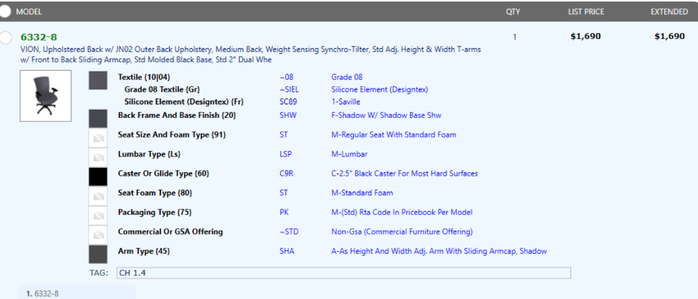
*** A few things, the product number for the first item is incorrect. Correct spec is attached. Also, the antique copper on our Sonoma bedside table isn’t an option as this finish is being discontinued. Would they like us to use tungsten instead? ***

END OF DOCUMENT

