R E Q U E S T f o r Q U A L I F I C A T I O N S

ALL PROSPECTIVE ARCHITECTURAL / ENGINEERING / GENERAL CONTRACTING FIRMS

INVITATION for QUALIFICATIONS
NEW MEDIVATOR ROOM
GHS-FD Project #:
21502

Grady Health System Department of Facilities Development is soliciting “Qualifications” A/E/C services for an expansion of our central sterile operations with the addition of a new medivator room. A brief graphical overview of the project is included on the next page of this document.

The project will be located at the main hospital.
- 80 Jesse Hill Jr. Drive, SE, Atlanta, GA 30303.

All A/E/C firms planning to partner and submit a proposal must be qualified. To become qualified, please submit a qualifications package meeting the following requirements:
- List of three to five design-build projects of similar size and scale.
- Brief narrative of each of the referenced projects.
- Organization chart of your team
- One page CV or resume of each team member.

Additionally, registration with VendorMate and TIER 1 Diversity forms must also be completed in order to be considered qualified.

Please submit qualifications to Stacy Parker by email at saparker@gmh.edu by C.O.B. August 26, 2022.

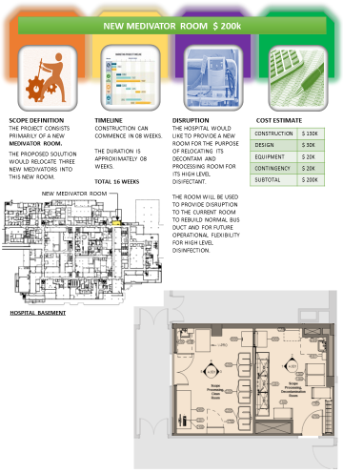
Figure #1 – New Medivator Room Concept

Local, Small Economically Disadvantaged Business Utilization
It is an overall objective of The Grady Memorial Hospital Corporation, d/b/a Grady Health System (GHS) to encourage involvement by local, small, economically disadvantaged contractors and suppliers in business activities generated by GHS®, while assuring that such activities will be conducted in accordance with all applicable laws. It is the declared policy and intent of GHS® to strive to maximize participation of local, small, economically disadvantaged businesses through all business contracting opportunities. GHS® is committed to ensuring that local, small, economically disadvantaged businesses are given every opportunity to participate in contracting opportunities.

GHS® prohibits discrimination on the basis of race, color, gender, religion, national origin, or disability in connection with employment of any person, or the award of any contract. GHS® will provide equal opportunities without regard to race, color, gender, religion, national origin, or disability, by requiring that any vendor doing business with GHS® provide equal opportunity to persons and businesses employed by, or contracting with the supplier of products and services to GHS®.

GHS® expects that the policies, programs and practices of its vendors/contractors are carried out in an equitable fashion and that local (Fulton County, DeKalb County, State of Georgia), small and economically disadvantaged business enterprises are afforded an equitable opportunity to share in contract/subcontract opportunities.

These documents are considered a part of and should be submitted with the qualifications package. Failure to provide the requested information will result in the proposal being determined non-responsive.

- Screen shot or copy of Vendormate certificate
- Completed TIER 1 Diversity form
- Certificate verifying TIER 1 diversity.
- List of three to five design-build projects of similar size and scale.
- Brief narrative of each of the referenced projects.
- Organization chart of your team
- One page CV or resume of each team member.

PROCESS FOR SELECTION

A selection team will evaluate each qualification submitted and score the team member. The scores will be made available upon request for your team following qualification

GHS-FD reserves the unqualified right to request additional information or meetings with any architect, engineer, or contractor.

Your company wishes to be qualified as a:

⃝ Architect

⃝ Engineer

⃝ General Contractor

NAME: TITLE:

PHONE: ( ) EMAIL:

SIGNATURE: DATE:

